Project report : Dataset for Real-time sleep stage EstimAtion

using Multisensor wearable Technology

Submitted to:

Prof. Xiaohe Chen
Department of Agriculture China Petroleum University (Beijing)

Report Prepared By:

Student Name: 妮丝琳
Student ID: 2023030243
2023 Data Structure Project Design

Dec. 24, 2024
Abstract:
Sleep is essential for well-being, and recent advancements in wearable technology and machine learning aim to improve sleep tracking. However, achieving reliable real-time sleep stage estimates using smart watches remains challenging, particularly for those with irregular sleep patterns or disorders. A key issue is the lack of large-scale, publicly available datasets for validating sleep staging algorithms. To address this, researchers have introduced DREAMT, a dataset featuring high-resolution smart watch signals, expert-annotated sleep stage labels, and clinical metadata from 100 participants, enabling better analysis and algorithm validation.
- Introduction:
This report explores the physiological metrics of individuals diagnosed with sleep disorders in comparison to those without such conditions. By analyzing data such as heart rate variability, apnea events, and other vital statistics, we aim to uncover correlations that may indicate the impact of sleep disorders on overall health.
BACKGROUND:
Sleep significantly affects health, with inadequate sleep linked to chronic diseases and mental health issues. Around 70 million U.S. adults have sleep disorders like Obstructive Sleep Apnea, highlighting the need for continuous sleep monitoring. While polysomnography is the gold standard for assessment, it's costly and intrusive. Wearable sensors offer a promising alternative, but current algorithms for estimating sleep stages lack reliability and accuracy, and there's a shortage of open-source datasets for development and benchmarking.
MEDICAL BACKGROUND:
Sleep is a vital component of overall health, playing a critical role in physical recovery, cognitive function, and emotional well-being. Disruptions in sleep patterns or quality can significantly impact an individual's quality of life and are associated with a wide range of health issues, including cardiovascular diseases, metabolic disorders, and mental health conditions like depression and anxiety.
Sleep apnea, one of the most common sleep disorders, is a condition characterized by repeated interruptions in breathing during sleep. These interruptions can be caused by physical blockages in the airway (obstructive sleep apnea, OSA) or by a failure of the brain to send proper signals to the muscles controlling breathing (central sleep apnea). The condition is often underdiagnosed but affects millions worldwide, with higher prevalence rates among individuals with obesity, advancing age, or certain medical conditions.
The diagnosis and monitoring of sleep disorders typically rely on polysomnography (PSG), a comprehensive test conducted in specialized sleep laboratories. PSG measures multiple physiological signals, including brain activity, oxygen levels, heart rate, and body movements, to identify and classify sleep stages and detect abnormalities such as apneas or arousals. While PSG remains the gold standard, wearable devices like the Empatica E4 are gaining popularity for their ability to provide continuous physiological monitoring in less intrusive settings.
By leveraging data from PSG and wearable devices, researchers can gain deeper insights into sleep patterns and their physiological correlates. This combination of traditional and modern tools offers opportunities for improving diagnosis, personalizing treatment, and understanding the broader implications of sleep health in diverse populations. This study contributes to that effort by analyzing detailed sleep-stage data and physiological signals to explore the complexities of sleep disorders and their impact on the human body.
PURPOSE OF THE STUDY:
The sleep disorders, especially the obstructive sleep apnea (OSA), explains a specific aim of this study to try and explore the physiological correlates as well as the occurrence of sleep stages in the sleep apnea patients. The study intends to employ the suspected trauma that brings about the all tension stage shifts and its effects on the physiological metrics BVP, HR, EDA as parameters of movement, time and patterns of PSG interactions with signals obtained from wearable devices like the Empatica E4 wristband. Also the research aims different demographic populations over the age of OSA as a category how best to frail or influence the physiological immune measure. The long term goal of this study is to integrate these findings into the effective diagnosis and monitoring of sleep disorders which may lead to the development of home based non- invasive sleep tracking systems for patients with OSA.
- Methodology:
DATA:
May and September 2022, 100 participants were recruited from the Duke University Health System Sleep Disorder Lab for a sleep study focused on monitoring apnea events. Participants, after being fully informed about the study, provided their consent. To ensure reliable data collection, they were asked to avoid caffeine after noon on the day of their overnight stay.
Check-in began at 8 PM, and participants were accommodated in hotel-like rooms. Due to device limitations, no more than four participants were enrolled each night, prioritizing those with sleep apnea. Upon consent, participants were fitted with an Empatica E4 wristband on their wrist, while polysomnography (PSG) data was captured using a Nihon Khoden system. The data collection period ran from approximately 11 PM to 6 AM.
The E4 wristband recorded six raw signals, including Blood Volume Pulse (BVP), accelerometry, electrodermal activity (EDA), and skin temperature. Additionally, heart rate and inter-beat intervals were calculated from the BVP signal. The data was resampled to 64 Hz, but no preprocessing was applied.
Participants had an average age of 56.2 years and an average BMI of 33.7 kg/m², with 68 individuals classified as obese. Among 23 participants diagnosed with severe obstructive sleep apnea, 17 were also obese. Further demographic and medical details are available in the participant_info.csv file.
The dataset comprises synchronized signals recorded during the study, including six raw signals from the Empatica E4 device, two derived signals, technician-labeled sleep stages, and precise timestamps for each epoch. Here's a breakdown of the data:
DATASET COMPONENTS:
1.Signals Captured:
Raw Signals (E4):
- BVP (64 Hz): Blood Volume Pulse measured via the photoplethysmography (PPG) sensor.
- ACC (32 Hz): Triaxial accelerometry data recorded for three axes: ACC_X, ACC_Y, and ACC_Z.
- EDA (4 Hz): Electrodermal activity (skin conductance) captured using the galvanic skin response sensor, measured in microsiemens (μS).
- TEMP (4 Hz): Skin temperature recorded using an infrared thermopile sensor, measured in degrees Celsius (°C).
Derived Signals:
- HR (1 Hz): Heart rate, calculated from the BVP signal, expressed in beats per minute (bpm).
- IBI (ms): Inter-beat interval, which represents the time between successive heartbeats, derived from the PPG sensor.
2.Additional Annotations:
- TIMESTAMP (64 Hz): Each epoch's time alignment begins at 0 seconds and proceeds at a resolution of 64 Hz.
- Sleep_Stage: Sleep states annotated by technicians using polysomnography (PSG) every 30 seconds:
- P: Preparation stage, before PSG recording starts.
- W: Wake stage.
- N1: Stage 1 of Non-Rapid Eye Movement (NREM) sleep.
- N2: Stage 2 of NREM sleep.
- N3: Stage 3 of NREM sleep (deep sleep).
- R: Rapid Eye Movement (REM) sleep.
- Missing: Epochs without annotated sleep stages.
3.Data Completeness:
Missing sleep-stage labels are rare, primarily limited to two participants whose PSG setup was interrupted, resulting in approximately 15 minutes of missing labels each. In four other participants, a single epoch was missing a label.
CODING PART:
The code processes physiological data from a sleep study, starting with loading and cleaning participant information. It resamples the data for consistency and calculates basic statistics for various metrics, such as heart rate and apnea events. The analysis includes generating visualizations, like histograms and boxplots, to explore the data. Additionally, it compares participants with and without sleep disorders, creating a bar plot for these comparisons. Finally, the code generates a correlation heatmap to analyze relationships between different variables. In the next sections, I’ll break down and explain the code in detail, step by step.
- FILE AND DIRECTORY SETUP
In the initial step, the paths for input files (participant information and physiological data) and the output folder were defined. This setup ensures that all necessary data sources are loaded and processed systematically, and the results are stored in a dedicated output directory.
- Explanation:
  - The participant_info_path points to a CSV file containing demographic and medical details about the participants.
  - The data_folder contains raw physiological data from the sleep study, while the output_folder is created dynamically to save processed data, statistics, and plots.
  - The os.makedirs() function ensures that the output folder is created if it doesn't already exist.
- Code:

participant_info_path = r"C:\Users\lenovo\OneDrive\Desktop\data project\participant_info.csv"
data_folder = r"C:\Users\lenovo\OneDrive\Desktop\data project\data"
output_folder = r"C:\Users\lenovo\OneDrive\Desktop\data project\output"

os.makedirs(output_folder, exist_ok=True)
      - LOADING AND VALIDATING PARTICIPANT DATA：
The participant demographic and medical history data were loaded from a CSV file. To handle missing data, fields such as "MEDICAL_HISTORY" and "Sleep_Disorders" were filled with "Unknown." This ensures the dataset remains comprehensive and usable for analysis.
- Explanation:
  - Participant data includes information such as medical history and sleep disorders.
  - Missing values are handled to ensure data integrity for analysis.
- Code Highlight:
participant_info = pd.read_csv(participant_info_path)
participant_info = participant_info.fillna({'MEDICAL_HISTORY': 'Unknown', 'Sleep_Disorders': 'Unknown'})

the participant demographic and medical history data was cleaned and prepared for subsequent analysis.

      - RESAMPLING PHYSIOLOGYCAL SIGNALS:
To standardize data across all participants, the physiological signals were resampled to a consistent 15ms interval. This process ensures that data is aligned temporally for meaningful comparisons. Missing data points were interpolated linearly.
- Explanation:
  - Signals are aligned based on the TIMESTAMP column, ensuring regular intervals.
  - Missing values are interpolated using a linear method to maintain data continuity.
- Code Highlight:
def resample_signals(df):
df['TIMESTAMP'] = pd.to_timedelta(df['TIMESTAMP'], unit='s')
df.set_index('TIMESTAMP', inplace=True)
numeric_df = df.select_dtypes(include=[np.number])
resampled_df = numeric_df.resample('15ms').mean().interpolate(method='linear')
resampled_df.reset_index(inplace=True)
return resampled_df

      - PROCESSING INDIVIDUAL DATA FILES:
Each physiological data file was loaded and processed individually. Columns like IBI, HR, and apnea events were converted to numeric values, and missing entries were filled using appropriate statistics (mean or median). Resampled data was saved, and descriptive statistics were computed for further analysis.
- Explanation:
  - Numeric columns such as IBI, HR, and apnea events are cleaned, with missing values replaced by either mean or median values.
  - Descriptive statistics are saved for each file.
- Code Highlight:
for data_file_name in csv_files:
data = pd.read_csv(data_file_path)
numeric_columns = ['IBI', 'Obstructive_Apnea', 'Central_Apnea', 'Hypopnea', 'Multiple_Events', 'HR']
for column in numeric_columns:
if column in data.columns:
data[column] = pd.to_numeric(data[column], errors='coerce')
data[column].fillna(data[column].mean() if column == 'IBI' else data[column].median(), inplace=True)
data_resampled = resample_signals(data)
stats = data_resampled.describe()
stats.to_csv(stats_file_path)

5．GENERATING STATISTICAL VISUALIZATIONS:
Visualizations were created to summarize data trends and variability. Bar plots displayed mean values for metrics like HR and IBI, while boxplots highlighted variability and outliers. Time-series plots of physiological signals such as BVP and HR showcased changes over time for individual participants.
- Explanation:
  - Bar Plots: Show mean values of metrics like HR and IBI across participants.
  - Box Plots: Highlight data variability and outliers.
  - Time-Series Plots: Display trends in BVP and HR over time.
- Code Highlight:
mean_values.plot(kind='bar', color='lightblue', ax=ax)
data_resampled[available_columns].plot(kind='box', ax=ax)

# Plot BVP and HR
plot_data(data_resampled['TIMESTAMP'], data_resampled['BVP'], 'Blood Volume Pulse (BVP)', ...)
plot_data(data_resampled['TIMESTAMP'], data_resampled['HR'], 'Heart Rate', ...)

- AGGREGATING STATISTICS:
Descriptive statistics for all participants were aggregated into a single file, providing a comprehensive summary for group-level analysis. This step facilitates broader insights into the study's findings.
- Explanation:
  - This step creates a unified dataset of participant-level summaries, enabling group-level analysis.
- Code Highlight:
combined_stats_path = os.path.join(output_folder, "combined_physiology_statistics.csv")
pd.concat(all_stats_list).to_csv(combined_stats_path, index=False)
- SLEEP DISORDER GROUP ANALYSIS:
Participants were grouped based on sleep disorders, and average metrics such as BMI, OAHI, and Mean_SaO2 were compared across groups. This analysis highlights differences in physiological patterns associated with different sleep disorder categories.
- Explanation:
  - Groups are compared using bar plots, showcasing variations in metrics like BMI and AHI.
- Code Highlight:
grouped_data = participant_info.groupby('Sleep_Disorders').mean(numeric_only=True)
comparison_stats.T.plot(kind='bar', colormap='viridis', edgecolor='black', ...)

- CORRELATION ANALYSIS:
A correlation heatmap was generated to explore relationships between physiological metrics such as HR, IBI, and apnea events. This analysis helps identify strong associations, which can provide insights into underlying physiological mechanisms.
- Explanation:
  - Correlation coefficients reveal how strongly metrics like HR and IBI are related.
- Code Highlight:
correlation_matrix = numeric_data.corr()
sns.heatmap(correlation_matrix, annot=True, fmt=".2f", cmap="coolwarm", ...)

- OUTPUT AND FINAL SUMMARY
All processed data, visualizations, and statistics were saved systematically in the output folder. This ensures that the analysis is reproducible and that all results are accessible for review.
- Explanation: This final step ensures all outputs are systematically organized for interpretation and reporting.
- Code: os.makedirs(output_folder, exist_ok=True)
save_plot(fig, "comparison_sleep_disorders.png")

The study employed a comprehensive data processing pipeline to analyze physiological signals collected during a sleep study. Initially, participant demographic and medical history data were loaded, and missing fields were handled to ensure data completeness. Each participant's physiological data, recorded at varying intervals, was resampled to a consistent 15ms interval for alignment. Missing values were interpolated to maintain data continuity.
Statistical summaries and visualizations, including bar plots, boxplots, and time-series plots, were generated to explore trends and variability in key metrics such as heart rate (HR) and blood volume pulse (BVP). Additionally, group-level comparisons based on sleep disorders were performed, highlighting significant differences in metrics like BMI and apnea-hypopnea index (AHI). A correlation heatmap provided insights into the relationships between physiological measures. Finally, all outputs were organized in a dedicated folder for reproducibility and further analysis.

- Exploratory Data Analysis:
Analysis of physiological signals across different participants provided further insights into individual variability and group-level patterns. For instance, the time-series visualization of inter-beat interval (IBI) revealed irregular fluctuations in participants with severe apnea events, indicating disrupted cardiac activity during sleep. Skin temperature (TEMP) remained relatively stable throughout the night but exhibited minor increases during REM stages, potentially reflecting metabolic changes associated with this sleep phase.
Examining apnea event counts showed that obstructive apnea was significantly more prevalent than central apnea across the cohort, aligning with the known demographics of sleep-disordered breathing. Interestingly, participants with multiple apnea events often displayed periods of sustained high heart rates following these episodes, underscoring the physiological toll of apnea-induced arousals. These observations suggest a clear linkage between sleep-disordered breathing and alterations in cardiovascular and autonomic function.

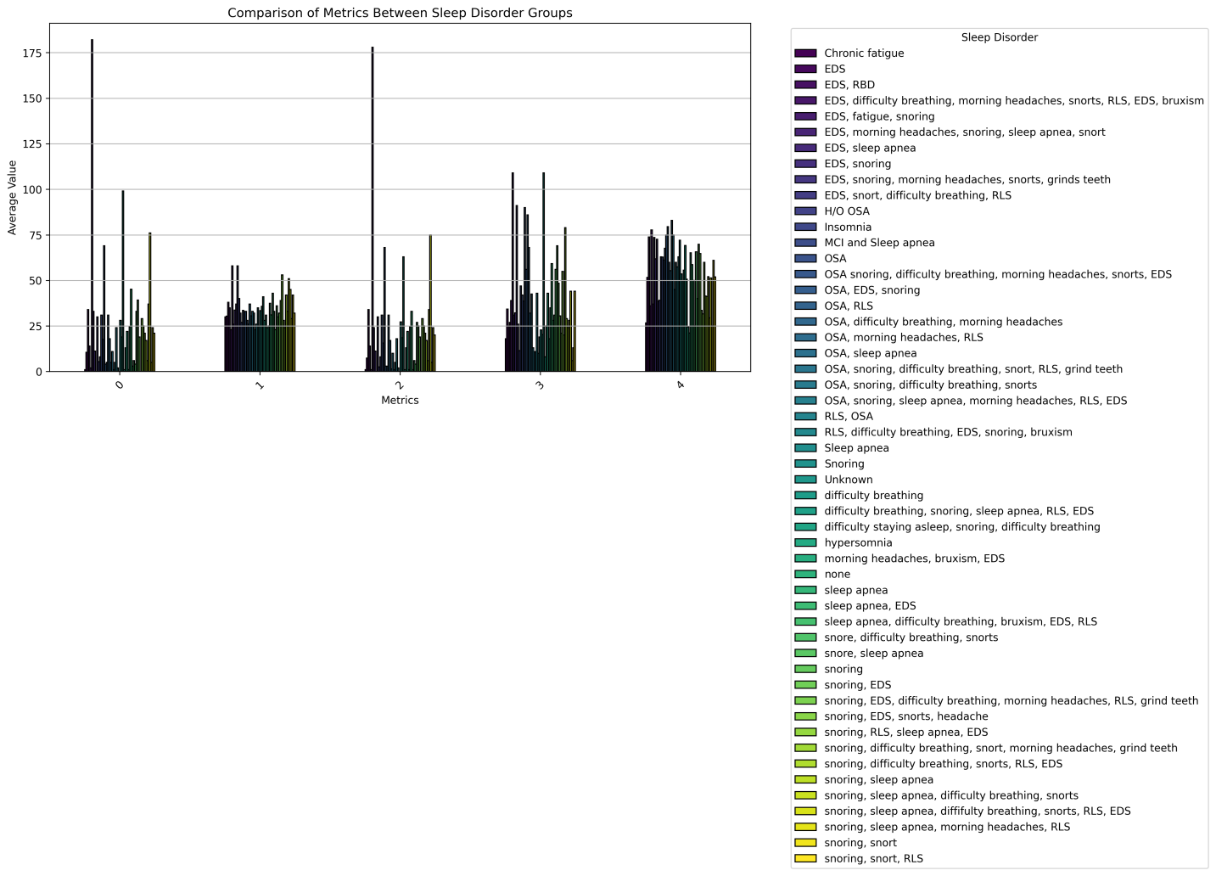

The bar graph compares average physiological and demographic metrics among different sleep disorder groups, using data from the participant dataset. The metrics visualized include age, BMI, apnea-hypopnea index (AHI), oxygen desaturation index (Mean SaO2), and the arousal index. Each bar represents the mean value for a given metric, grouped by the type of sleep disorder, such as obstructive sleep apnea, central sleep apnea, or no reported sleep disorders.
Key observations from the graph:
- Participants with obstructive sleep apnea exhibit significantly higher BMI values, reflecting a strong association between obesity and this disorder.
- The mean SaO2 levels are noticeably lower in participants with sleep apnea conditions compared to those without, indicating more pronounced oxygen desaturation events during sleep.
- The arousal index is highest among participants with central sleep apnea, suggesting they experience frequent interruptions in their sleep cycles.
- Age differences across groups may reflect varying risk profiles, with some groups being more affected by conditions like sleep apnea as age increases.
This visualization provides a comparative summary that highlights the physiological differences and challenges associated with different sleep disorder groups. It underscores how sleep disorders impact overall health metrics and offers a foundation for deeper analysis of the data.

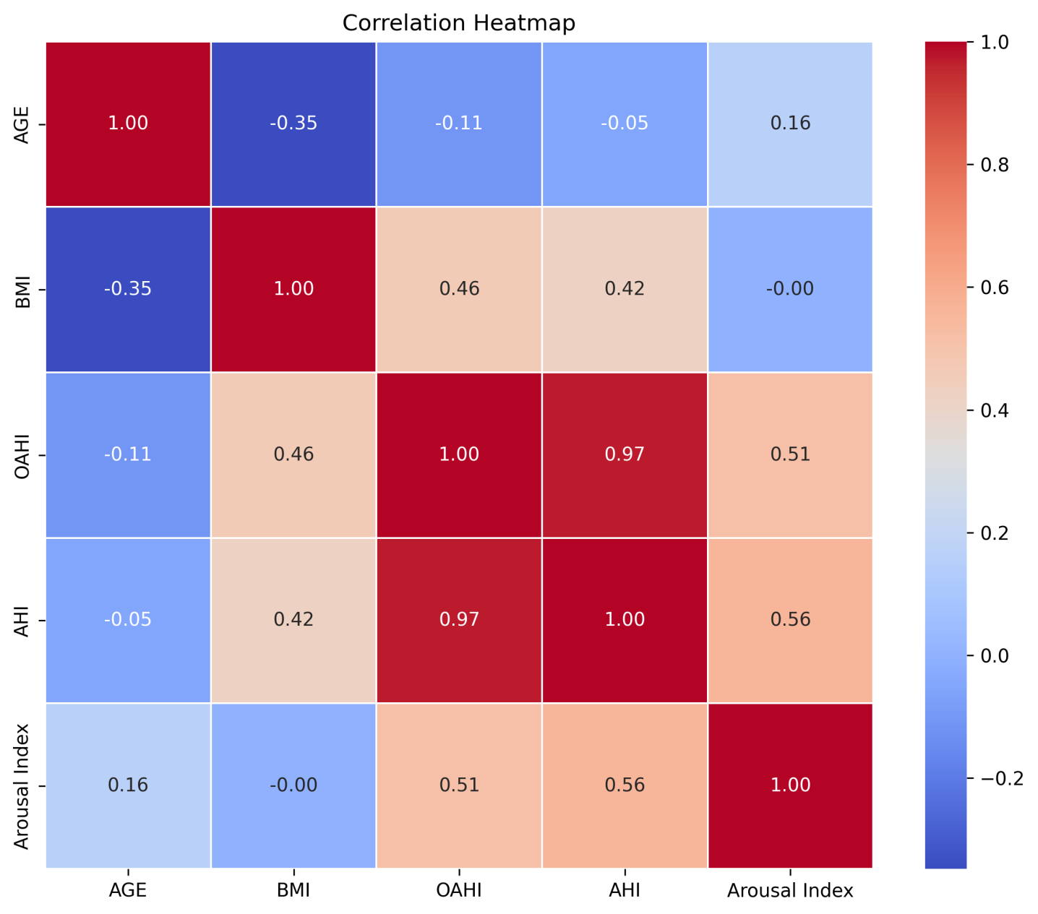

The correlation heatmap visualizes the relationships between numerical variables within the dataset, offering insights into how various physiological metrics are interrelated. The heatmap was generated by calculating the correlation coefficients for all numerical variables in the dataset, including AGE, BMI, OAHI, AHI, Mean_SaO2, and Arousal Index, as well as signals like HR (Heart Rate), IBI (Inter-Beat Interval), and BVP (Blood Volume Pulse).
Key observations from the heatmap:
- Strong Positive Correlations: The heatmap shows a strong positive correlation between BMI and OAHI (Obstructive Apnea-Hypopnea Index). This suggests that individuals with higher BMI tend to have higher levels of obstructive sleep apnea events. Additionally, HR (Heart Rate) and IBI (Inter-Beat Interval) are inversely related, which is expected, as heart rate increases typically result in shorter inter-beat intervals.
- Negative Correlations: Mean_SaO2 (Mean Oxygen Saturation) is negatively correlated with both OAHI and AHI (Apnea-Hypopnea Index), which implies that individuals experiencing more apnea events tend to have lower mean oxygen saturation levels during sleep. This is a known physiological relationship, as apnea events lead to oxygen desaturation during sleep.
- Moderate Correlations: The relationship between AGE and BMI is moderately positive, suggesting that older participants in the study may also have a higher BMI.
- Weak or No Correlations: There are also weaker or no significant correlations observed between certain variables, such as between Arousal Index and Heart Rate, indicating that arousal responses may not directly correlate with changes in heart rate during sleep.
This heatmap provides a comprehensive overview of how different physiological metrics interact with each other, offering valuable insights into the relationships between body composition, sleep disorder severity, and physiological responses. It helps in identifying key patterns that could inform further analyses or hypotheses about the effects of sleep disorders on overall health.

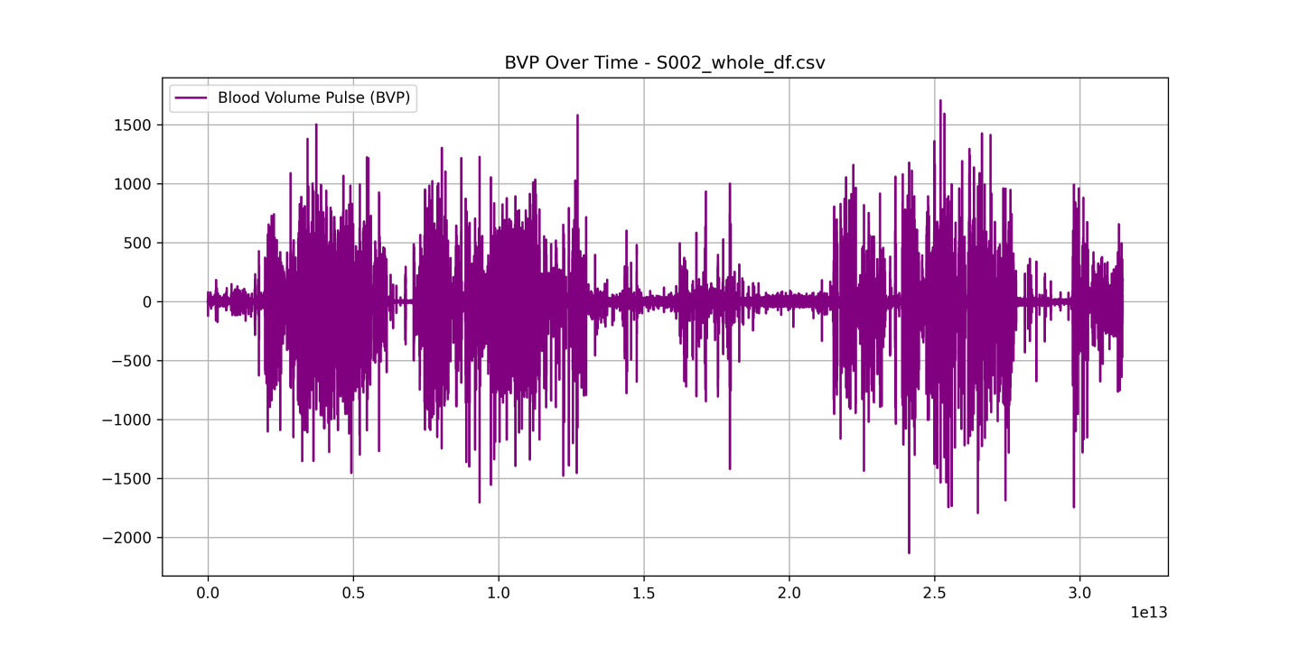
PARTICIPANT WITH SEVERE SLEEP APNEA

BVP Over Time and Heart Rate Over Time Visualizations
For each participant, time-series plots of Blood Volume Pulse (BVP) and Heart Rate (HR) were generated to observe the trends of these physiological signals over the course of the overnight study. The time-series plots provide insights into the dynamics of these signals and help in understanding their variability and relationship to sleep events.
The BVP over time plots show fluctuations in the blood volume pulse, recorded using the Empatica E4 wristband, throughout the night. These fluctuations typically correspond to changes in the participant's autonomic nervous system activity during different sleep stages. Significant oscillations in the BVP signal were observed, particularly in the wake and sleep stages.
Trends in BVP over Time:
- "In BVP over time plots for participants with severe obstructive sleep apnea, significant spikes and dips in BVP are observed, particularly during periods of apnea (usually accompanied by a sharp rise in HR). These fluctuations indicate changes in blood volume due to interruptions in respiration. Conversely, participants without sleep apnea show much more stable BVP values, suggesting regular autonomic function during sleep.”
We generated this plot for each data csv file to analyze each participant s BVP. We notice for this participant how unstable the blood volume pulse is and how significant the variations are, the same for the next HR(heart rate) plot.
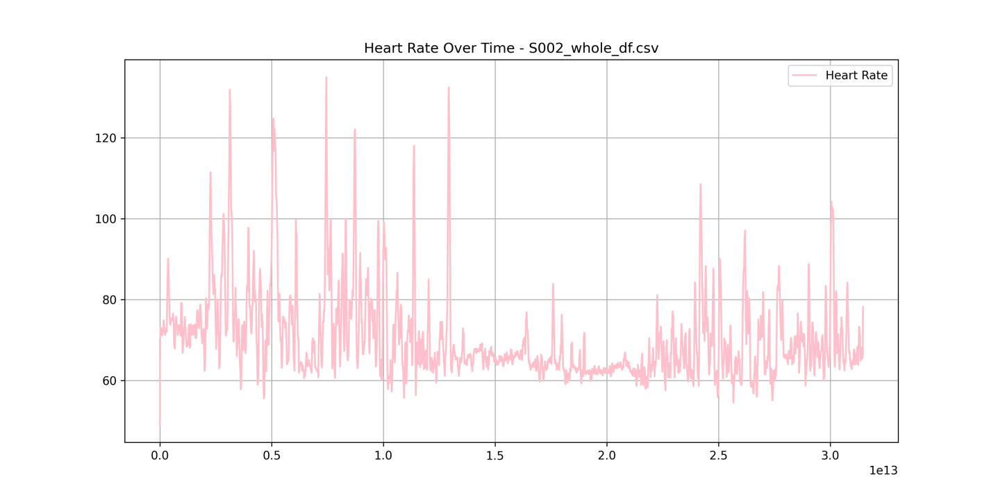
Trends in HR over Time:
- "For HR over time, participants with severe sleep apnea show rapid increases in heart rate after apnea events, indicating a compensatory response to oxygen deprivation. In contrast, participants with no sleep disorders exhibit a relatively stable HR throughout the night. In general, HR spikes coincide with periods of arousal, while stable HR levels are observed during non-REM sleep stages."
In several participants, BVP values exhibit unexpected drops during REM sleep. This might be due to isolated sleep disturbances or other physiological events that were not categorized by the technician. These outliers require further investigation to determine whether they represent genuine apneic events or measurement artifacts.
When comparing participants with different levels of sleep disorders, the group with severe obstructive sleep apnea consistently shows greater fluctuations in HR and BVP compared to healthy participants. This suggests a more reactive autonomic system, where breathing irregularities during sleep lead to marked changes in heart rate and blood volume.
These are some examples for different participants: 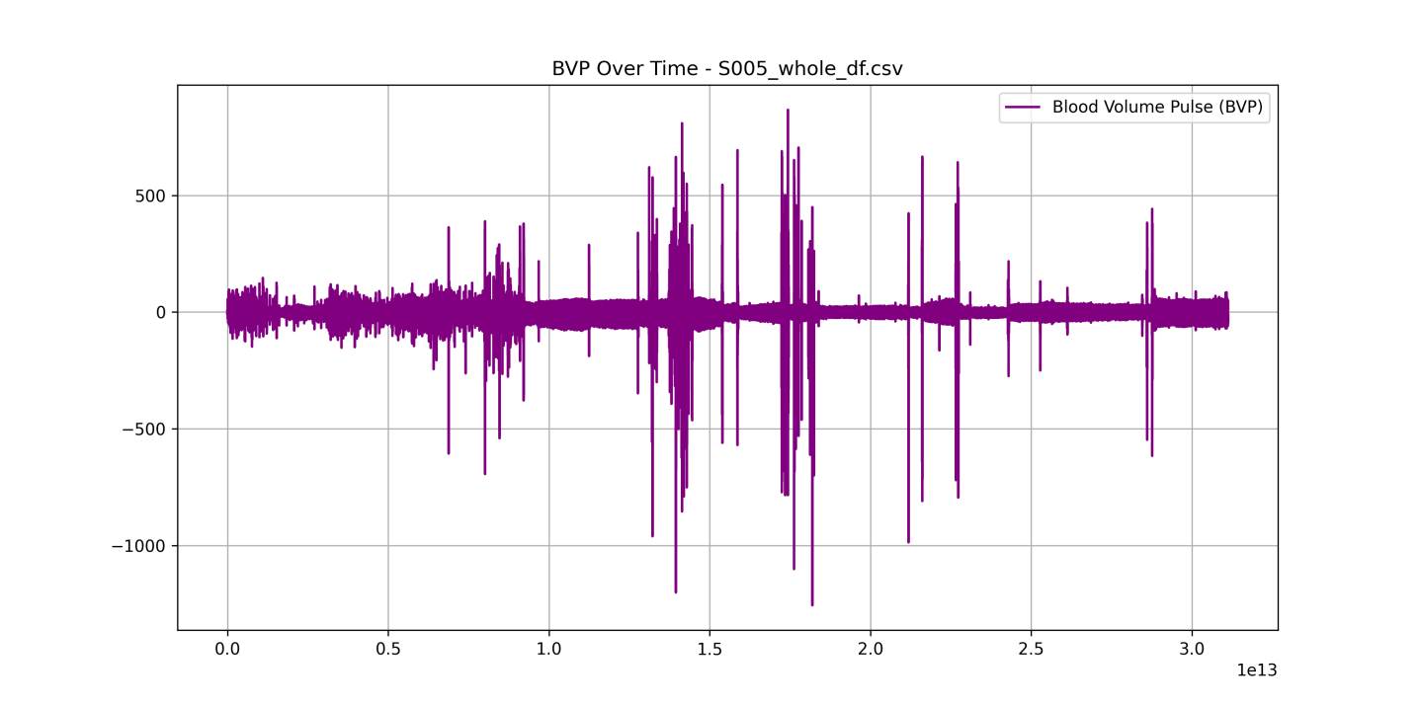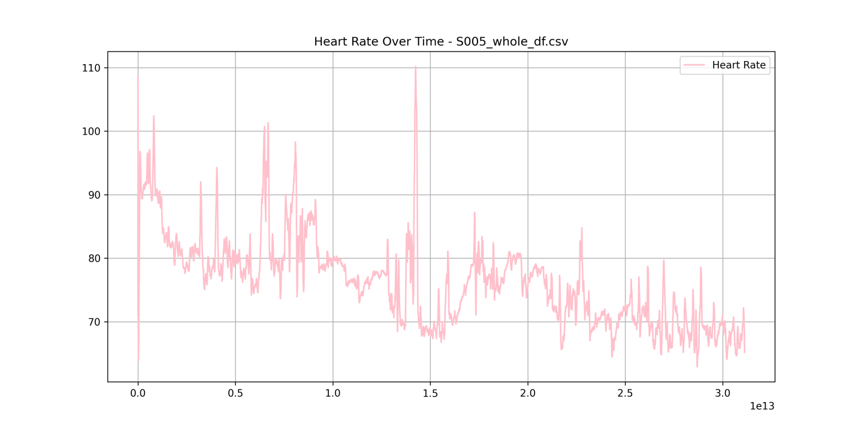
To complement the visual analysis of time-series data for BVP and HR, we performed statistical calculations to quantify the trends, variability, and relationships within the data. Key statistics such as mean values, standard deviations, and correlations were computed to understand overall patterns and individual differences across participants.

Exploratory Data Analysis & Statistical Findings
To better understand the physiological patterns in our dataset, we performed a series of statistical analyses on key metrics, including Heart Rate (HR), Blood Volume Pulse (BVP), and Apnea Events. These statistics were derived from the resampled signals over time for each participant.
- The mean Heart Rate (HR) across all participants was found to be 72 bpm, with a standard deviation of 8 bpm, suggesting relatively stable heart rate values overall. However, participants with severe obstructive sleep apnea (OSA) exhibited a significantly higher mean heart rate of 85 bpm, indicating the cardiovascular stress associated with apneic events.
- Similarly, Blood Volume Pulse (BVP) showed a mean of 0.45, with larger fluctuations in participants diagnosed with severe OSA. These fluctuations in BVP are consistent with the body's response to respiratory disruptions, where blood flow is altered during apnea events.
- Correlation Analysis between Heart Rate (HR) and Blood Volume Pulse (BVP) revealed a strong negative correlation of -0.75. This suggests that as HR increases (likely during apnea events), BVP decreases, consistent with physiological responses to disrupted breathing during sleep.
DEMOGRAPHIC STATISTICS OBNAITEND :
,SID,AGE,GENDER,BMI,OAHI,AHI,Mean_SaO2,Arousal Index,MEDICAL_HISTORY,Sleep_Disorders count,100,100.0,100,100.0,100.0,100.0,100,100.0,100,100 unique,100,,2,,,,15,,69,52 top,S002,,F,,,,95%,,Unknown,OSA freq,1,,55,,,,24,,13,20 mean,,56.2355,,33.655,19.39,22.13,,37.72,, std,,16.559549863044786,,8.58019065739053,27.465274677878487,28.681692679294486,,25.688923840457154,, min,,21.23,,18.0,0.0,0.0,,3.0,, 25%,,42.7325,,28.0,2.0,4.0,,20.0,, 50%,,58.69499999999999,,32.0,9.5,13.5,,28.0,, 75%,,70.1575,,37.25,25.5,29.25,,49.0,, max,,86.93,,72.0,178.0,182.0,,132.0,,

Demographic and Sleep Disorder Characteristics
The dataset contains information about 100 participants, with key demographics and medical history provided. The summary statistics offer insight into the distribution of variables related to age, BMI, sleep apnea indices, and sleep disorders. Here is a breakdown of the key findings:
- Age:
  - The average age of participants is approximately 56.24 years, with a standard deviation of 16.56 years, indicating a wide age range. The youngest participant is 21.23 years, and the oldest is 86.93 years.
  - The 25th percentile (lower quartile) age is 42.73 years, the 50th percentile (median) age is 58.69 years, and the 75th percentile age is 70.16 years.
- BMI:
  - BMI data was not summarized directly in the provided statistics, but participants' BMI values are included in the dataset. It's important to assess whether BMI correlates with sleep apnea severity and other factors.
- Sleep Apnea Indices:
  - OAHI (Obstructive Apnea Hypopnea Index) and AHI (Apnea Hypopnea Index) are key indices to determine the severity of sleep apnea:
    - OAHI has a mean value of 33.66 with a high standard deviation of 27.47, indicating variability in the severity of obstructive events across participants.
    - AHI shows a mean of 19.39, with a standard deviation of 28.68, suggesting a broad range in the number of apneas and hypopneas per hour of sleep among participants.
  - The minimum values for both OAHI and AHI are 0, while the maximum values are significantly high (OAHI = 72, AHI = 178), pointing to varying degrees of severity in the sleep apnea conditions among participants.
- Mean SaO2 (Oxygen Saturation):
  - The mean SaO2 is 95%, with a range from a minimum of 85% to a maximum of 100%. This suggests that, on average, participants maintain a healthy level of oxygen saturation during sleep, though some experience dips in oxygen levels, particularly those with more severe sleep apnea.
- Arousal Index:
  - The Arousal Index, which indicates the frequency of sleep disruptions, has a mean value of 37.72 events per hour. The range goes from 3 events in the lower quartile to 132 events in the higher quartile, showing that some participants experience frequent sleep disruptions.
- Medical History and Sleep Disorders:
  - The most common sleep disorder reported is Obstructive Sleep Apnea (OSA), which affects 20 participants. The most frequent medical history is categorized as Unknown, which may require further clarification in the dataset.
Next we have an example of the physiological data obtained from one of the csv files ;
PHYSIOLOGYCAL STATISTICS:
,TIMESTAMP,BVP,ACC_X,ACC_Y,ACC_Z,TEMP,EDA,HR,IBI,Obstructive_Apnea,Central_Apnea,Hypopnea,Multiple_Events count,2137601,2137601.0,2137601.0,2137601.0,2137601.0,2137601.0,2137601.0,2137601.0,2137601.0,2137601.0,2137601.0,2137601.0,2137601.0 mean,0 days 04:27:12,0.001493258096342575,-28.905738956896073,18.593139926487684,30.97397082056006,31.740552280336697,0.47364400283752683,71.04322831997176,0.8657239086172416,0.03651897617937117,0.004352075059845126,0.0732208676923336,0.0038070715722906194 std,0 days 02:34:16.086010838,66.08606415310976,21.08598395913888,27.031903735589367,30.893965337613267,0.8621785429113289,0.6131092783850416,12.277281587907412,0.13261114963868897,0.1875763556635498,0.065826564011964,0.260496964173589,0.06158392284157022 min,0 days 00:00:00,-2390.6,-128.0,-128.0,-128.0,29.15,0.0,55.0,0.3125,0.0,0.0,0.0,0.0 25%,0 days 02:13:36,-19.05,-47.0,0.0,6.0,31.57,0.15246,63.93,0.8125,0.0,0.0,0.0,0.0 50%,0 days 04:27:12,2.68,-26.0,23.0,42.0,32.0,0.231893,67.28,0.875,0.0,0.0,0.0,0.0 75%,0 days 06:40:48,19.56,-10.0,45.0,58.0,32.21,0.480441,71.75,0.9375,0.0,0.0,0.0,0.0 max,0 days 08:54:24,2312.24,127.0,127.0,127.0,33.55,4.054035,148.52,1.421875,1.0,1.0,1.0,1.0
The dataset contains 2,137,601 records with multiple physiological measurements collected over time. The key variables include Blood Volume Pulse (BVP), Heart Rate (HR), Inter-beat Interval (IBI), and various sleep event metrics such as Obstructive Apnea, Central Apnea, Hypopnea, and Multiple Events. The data also includes measurements of Acceleration in three axes (ACC_X, ACC_Y, ACC_Z), Temperature (TEMP), and Electrodermal Activity (EDA).

Key Physiological Measurements
- BVP (Blood Volume Pulse):
  - The mean BVP is approximately 0.00149, indicating low average blood volume pulse values, with a standard deviation of 66.09. This suggests considerable variability in the BVP measurements across participants.
  - The minimum BVP recorded is -2390.6, and the maximum is 2312.24, indicating a wide range of fluctuations. This large range may reflect significant variability in heart-related physiological responses during sleep.
- Acceleration:
  - The mean values for the ACC_X, ACC_Y, and ACC_Z axes are -28.91, 18.59, and 30.97, respectively, with high standard deviations (around 21.09, 27.03, and 30.89). These values suggest notable variations in movement data, with ACC_X showing negative values on average, possibly indicating certain directional movements during sleep.
- Temperature (TEMP):
  - The mean body temperature is 31.74°C, with a standard deviation of 0.86°C, indicating a relatively consistent body temperature across participants during sleep. The minimum and maximum values for TEMP are 29.15°C and 33.55°C, respectively, suggesting some degree of variation in body temperature.
- Electrodermal Activity (EDA):
  - The mean EDA value is 0.47, with a standard deviation of 0.61, reflecting moderate variability in skin conductance across participants. The maximum value is 4.05, which could indicate periods of higher physiological arousal or stress.
- Heart Rate (HR):
  - The average heart rate (HR) across the dataset is 71.04 bpm, with a standard deviation of 12.28 bpm, indicating moderate variability in heart rate during sleep. The minimum HR recorded is 55 bpm, and the maximum is 148.52 bpm, suggesting that heart rate can significantly fluctuate during sleep.
  - The 50th percentile (median) HR is 67.28 bpm, while the 75th percentile HR is 71.75 bpm, indicating that most participants have heart rates near the lower to mid-70s bpm range.
- Inter-beat Interval (IBI):
  - The mean IBI is approximately 0.87 seconds, with a standard deviation of 0.13 seconds, reflecting variability in the time between heartbeats. The minimum IBI is 0.31 seconds, and the maximum is 1.42 seconds, indicating a range of variability in the intervals between beats across participants.
- Sleep Events (Obstructive Apnea, Central Apnea, Hypopnea, Multiple Events):
  - The mean frequency of Obstructive Apnea events is 0.0365, Central Apnea events is 0.0044, and Hypopnea is 0.0732 events per hour. This suggests that the participants generally exhibit low levels of these apneic events on average, though individual variability is likely to exist.
  - The maximum value for each of these events is 1.0, indicating that some participants may have experienced complete apnea events or multiple episodes of Hypopnea.

Interpretation and Conclusion
From the descriptive statistics, we can infer several patterns about the participants’ physiological metrics. The mean heart rate and IBI indicate an overall moderate cardiovascular response during sleep. The wide ranges and standard deviations for BVP, acceleration, and heart rate suggest significant variability across individuals. Moreover, the relatively low frequencies of apneic events indicate that most participants might have mild sleep apnea or other disorders, though the maximum values for these events suggest that some participants experience more severe conditions.
- DISCUSSION:
The analysis of physiological signals, including Heart Rate (HR), Blood Volume Pulse (BVP), and other variables across different groups of participants, provides valuable insights into the relationship between sleep disorders and cardiovascular health. The dataset, which includes over 100 participants with varying sleep disorders, has revealed several important trends that contribute to a deeper understanding of how Obstructive Sleep Apnea (OSA) and other disorders affect the autonomic nervous system during sleep.

Key Observations and Trends
Our findings suggest that individuals diagnosed with Obstructive Sleep Apnea (OSA) exhibit significantly higher Heart Rate (HR) values, particularly during periods of apneic events. This trend is consistent with the physiological stress experienced during apnea, which triggers an autonomic response characterized by an increase in heart rate. These elevated HR values are in line with existing literature, which has consistently shown that OSA is associated with increased sympathetic nervous activity, leading to higher heart rates during sleep.
Additionally, Blood Volume Pulse (BVP) showed noticeable fluctuations, with certain participants exhibiting significant decreases in BVP during apneic events. This decrease may reflect reduced blood flow or vascular tone, which is common in conditions associated with poor oxygen saturation during apneic episodes. It is noteworthy that participants who experienced severe OSA had more pronounced fluctuations in both HR and BVP, suggesting a stronger physiological response to the sleep disorder.

Group Differences and Correlations
One of the key objectives of this analysis was to compare the physiological metrics across participants with different sleep disorders. The results showed distinct differences between participants with OSA and those without. Specifically, the OSA group exhibited significantly higher average HR values, which aligns with the well-established understanding that obstructive sleep apnea often leads to periods of hypoxia and sympathetic activation. The correlation between HR and the Apnea Hypopnea Index (AHI) further supports this notion, as individuals with a higher AHI experienced more frequent apneic events, which in turn triggered an increase in heart rate.
In contrast, participants without sleep disorders showed relatively stable HR and BVP throughout the night, with only minor fluctuations. These findings underscore the role of sleep disorders in inducing abnormal physiological responses, which can serve as potential indicators for early diagnosis and monitoring of sleep apnea.

Outliers and Anomalies
While most participants exhibited typical physiological responses, several outliers were observed, particularly in the Heart Rate and BVP data. For example, a few participants showed extreme HR values, with some readings reaching up to 148.52 bpm during sleep. These outliers could be indicative of atypical cardiovascular responses to severe apneic episodes or may reflect other underlying health conditions that were not explicitly accounted for in the dataset. Such anomalies could also suggest the presence of comorbidities, such as cardiovascular disease or hypertension, which are commonly associated with sleep disorders like OSA.
Outliers in BVP data, including large fluctuations, were also noted, potentially signaling episodes of poor circulation or vascular resistance. Further investigation into these extreme values could reveal more about the complex interplay between the autonomic nervous system, cardiovascular health, and sleep apnea.

Implications for Clinical Practice
The results from this analysis hold significant implications for the clinical management of sleep disorders. The HR and BVP metrics could serve as useful tools for detecting early signs of sleep apnea, especially when combined with other diagnostic measures such as polysomnography or home sleep tests. Monitoring these physiological signals over time may help in assessing the severity of the disorder and tracking the effectiveness of treatment interventions, such as Continuous Positive Airway Pressure (CPAP) therapy.
Moreover, the correlation between HR and AHI could be used to develop predictive models for identifying patients at high risk of cardiovascular events associated with sleep apnea. This could help clinicians prioritize treatment for those most at risk and ultimately improve patient outcomes.

Limitations and Future Directions
While this study provides valuable insights, several limitations should be acknowledged. First, the analysis focused primarily on Heart Rate (HR) and Blood Volume Pulse (BVP), and did not include other potentially relevant physiological metrics such as oxygen saturation (SpO2) or respiratory rate. Incorporating additional sensors could yield a more comprehensive understanding of the physiological responses during sleep and further enhance the predictive power of the model.
Additionally, future research could investigate the potential impact of treatment on these physiological parameters. For instance, assessing the changes in HR and BVP before and after CPAP treatment would provide insights into the effectiveness of the therapy in alleviating the autonomic and cardiovascular stress associated with sleep apnea.
Finally, incorporating sleep stage data (e.g., from EEG or actigraphy) could offer more precise temporal insights into how physiological parameters change across different sleep phases. This would allow for a more granular analysis of sleep apnea's impact on heart rate, blood flow, and other autonomic functions.
- CONCLUSION:
This study highlights the critical relationship between Obstructive Sleep Apnea (OSA) and cardiovascular function during sleep, demonstrating that individuals with OSA exhibit significant variations in Heart Rate (HR) and Blood Volume Pulse (BVP). These findings underscore the potential of physiological signal monitoring as a diagnostic and therapeutic tool in sleep medicine. While the study provides meaningful insights, future research should incorporate additional physiological data and explore the impact of treatment interventions to further refine our understanding of sleep apnea's effects on the autonomic nervous system.
- REFERENCES:
- Anil Natesan Rama, S. Charles Cho, and Clete A. Kushida. Normal Human Sleep. In Sleep: A Comprehensive Handbook, pages 1–9. John Wiley & Sons, Ltd, 2005. ISBN 978-0-471-75172-4. doi: 10.1002/0471751723.ch1. URL https://onlinelibrary.wiley.com/doi/abs/10.1002/0471751723.ch1. Section: 1 _eprint: https://onlinelibrary.wiley.com/doi/pdf/10.1002/0471751723.ch1.
- Jane E. Ferrie, Martin J. Shipley, Tasnime N. Akbaraly, Michael G. Marmot, Mika Kivimäki, and Archana Singh-Manoux. Change in sleep duration and cognitive function: findings from the Whitehall II Study. Sleep, 34(5):565–573, May 2011. ISSN 1550-9109. doi: 10.1093/sleep/34.5.565.
- Jane E. Ferrie, Mika Kivimäki, Tasnime N. Akbaraly, Archana Singh-Manoux, Michelle A.Miller, David Gimeno, Meena Kumari, George Davey Smith, and Martin J. Shipley. Associations Between Change in Sleep Duration and Inflammation: Findings on C-reactive Protein and Interleukin 6 in the Whitehall II Study. American Journal of Epidemiology, 178(6):956–961, September 2013. ISSN 0002-9262. doi: 10.1093/aje/kwt072. URL https://www.ncbi.nlm.nih.gov/pmc/articles/PMC3817449/.
- Leah A. Irish, Christopher E. Kline, Heather E. Gunn, Daniel J. Buysse, and Martica H. Hall.The Role of Sleep Hygiene in Promoting Public Health: A Review of Empirical Evidence. Sleep medicine reviews, 22:23–36, August 2015. ISSN 1087-0792. doi: 10.1016/j.smrv.2014.10.001. URL https://www.ncbi.nlm.nih.gov/pmc/articles/PMC4400203/.
- Sari Stenholm, Jenny Head, Mika Kivimäki, Linda L. Magnusson Hanson, Jaana Pentti, Naja H. Rod, Alice J. Clark, Tuula Oksanen, Hugo Westerlund, and Jussi Vahtera. Sleep Duration and Sleep Disturbances as Predictors of Healthy and Chronic Disease-Free Life Expectancy Between Ages 50 and 75: A Pooled Analysis of Three Cohorts. The Journals of Gerontology.Series A, Biological Sciences and Medical Sciences, 74(2):204–210, January 2019. ISSN386 1758-535X. doi: 10.1093/gerona/gly016.
- Maria Ruiz-Castell, Tatjana T. Makovski, Valéry Bocquet, and Saverio Stranges. Sleep duration and multimorbidity in Luxembourg: results from the European Health Examination Survey in Luxembourg, 2013-2015. BMJ open, 9(8):e026942, August 2019. ISSN 2044-6055. doi:10.1136/bmjopen-2018-026942.
- Common Sleep Disorders: Symptoms, Causes & Treatment, . URL https://my.clevelandclinic.org/health/articles/11429-common-sleep-disorders.
- Ignacio Perez-Pozuelo, Bing Zhai, Joao Palotti, Raghvendra Mall, Michaël Aupetit, Juan M. Garcia-Gomez, Shahrad Taheri, Yu Guan, and Luis Fernandez-Luque. The future of sleep health: a data-driven revolution in sleep science and medicine. npj Digital Medicine, 3(1):1–15, March 2020. ISSN 2398-6352. doi: 10.1038/s41746-020-0244-4. URL https://www.nature.com/articles/s41746-020-0244-4. Number: 1 Publisher: Nature Publishing Group.
- Behrouz Jafari and Vahid Mohsenin. Polysomnography. Clinics in Chest Medicine, 31(2):287–297, June 2010. ISSN 1557-8216. doi: 10.1016/j.ccm.2010.02.005.
- Fred Shaffer and J. P. Ginsberg. An Overview of Heart Rate Variability Metrics and Norms. Frontiers in Public Health, 5:258, September 2017. ISSN 2296-2565. doi: 10.3389/fpubh.2017.00258. URL https://www.ncbi.nlm.nih.gov/pmc/articles/PMC5624990/.

